# Clipped Head vs Round Head Framing Nailer

There can be a lot of controversies on which one wins the battle, but both are seemingly great in terms of usage. Yet a wide range of fanbase goes for clipped head framing nailers because they being comparative lightweight than the round head. Also, some additional key differences differ them from each other.

## Clipped head vs round head framing nailer

We following section will cover the individual identity of Clipped and round-headed ones and thus the controversial loop will be popped.

### Clipped Head Framing Nailer

Clipped head framing nails accept the clipped nails, which have a D-shaped pin-head. For alignment of more pins in a strip or coil, the pin-head shape is great. Even the magazine of the nailer can load more pins. Even though the magazine has a comparatively lower length yet, that doesn’t make a great difference.

The clipped nailer is genuinely light-weighted than that of an RHF nailer. Specifically, thus it is very much easy to deal with, and also some might complain about not having a tough stance while air-popping. Also, these happen to have 20-30% more pins than the round ones.

As most of the clipped nails are titled and organized in 22-34 degrees, so is the magazine of the clipped head framing nailer. Also. These types of nailers welcome clipped nails that are banded with papers. This gives a plain, light, safer working experience.

Check the details here, <https://www.youtube.com/watch?v=kcEX2esHLlc>

<https://www.youtube.com/watch?v=MXS4Z5fdXgU>

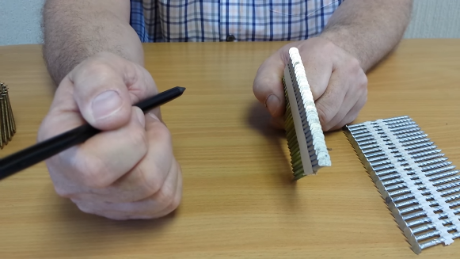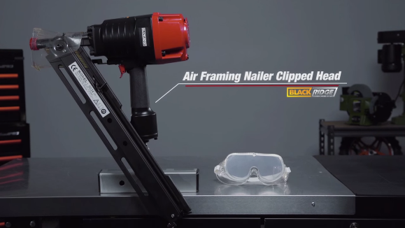

### Round Head Framing Nailer / RHF Nailer

The head-to-head fighter with a clipped head nailer is a workaholic in terms of giving the round head nails a better fit. A round head nail is simply a regular nail we can think of, with a circular disc-shaped head and ends with a sharp ending shaft.

The Roundhead nailer is comparatively heavy and thus gives a higher level of stance and grip while working. The fact is, round-headed nails occupy spaces similar to the diameter of the head, and in clipped nails, this space is reduced to a pretty great scale.

For a better lining and even edges of the sharp area of the shaft, these strips are also tilted, but due to the round head, these come with a lesser number of pins. However, the pins here are banded with either plastic or light gauge wires. So, when you work with them make sure you have extra safety and harmful for eyes when popping pins.

Hope on to the directs for more info, <https://www.youtube.com/watch?v=MXS4Z5fdXgU>

<https://www.youtube.com/watch?v=Mk8XO0YFGHo>

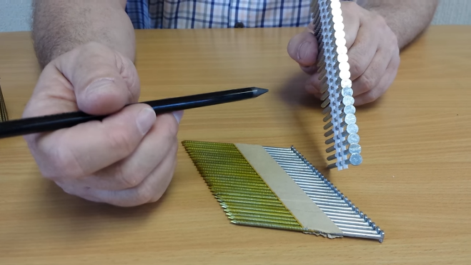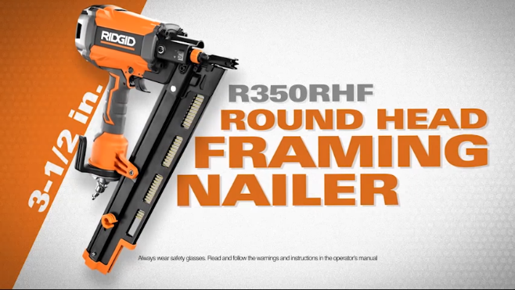

Keynotes to follow

Before looking for a nailer you better know the right purpose and the nails correspondingly. There are major thumbs up for both; while some even say round head can save you from a hurricane! Well, pins can’t assure with that much surety.

* But there are some sheer facts. A clipped nail can go deep inside the wood shreds even not keeping the trace of the pinhead. That might seem to be a great work finishing (which is technically right) but sometimes they pierce through the upper shred you are working with and rather than holding it tears it.
* While the round ones have the head to not let the whole shaft go beneath the depth. And also, you can visualize where you popped the pins and can do the extraction work later if needed.
* Both of the pins have holding power that is similar kind of, and many might say what’s the fuss with pinhead? Because you need to know your arena of work and if you wish you don’t need any trace of pins (not always omits trace) after work goes for clipped else round.
* Shafts have different patterns, and those have much to do with holding power; some spiral and some plain with the usual cuts.
* Another fact is the gauge size of the shafts, the higher size of the gauge often does not have heads even also, they are not finishing pins. Lower gauged pins are with the widen shafts and have more hold powers.

All these facts are more or less the key parts to take into consideration before selecting a nailer. Not that we only work on woods, the medium can be anything of choice, so the choice can vary.

## Can round pins work in a clipped head nailer?

Yes, you can you clipped head nailer for round pins as well, only if the pins are collated with paper tape. Clipped nailers only work with the collation that is banded with papers, that’s how it is regulated.

## What is the main difference between Clipped and Roundhead nailers?

The base variance for the nailers would be that clipped holds 20-30 percent more pins in the magazine of the nailers due to the D shape pins. Even if you compare to load both pins individually in clipped nailer, you’ll load fewer round pins where you could have loaded more in a round nailer.

This difference is because of the nailer design, so, it is

## 21-degree or 30-degree frame nailer, which is better?

30-degree nails are comparatively closer to each other and there can possibility of touching the shaft ends, and this can lead to a painful task. Whereas, 21 angular packs much better in terms of not having glitchy facts; smooth popping.

## FAQ

Can I use 30-degree nails in a 34-degree nailer?

This is possible indeed, to air-pop 30-degree nails from a 34-degree nailer. However, it is recommended to use a 34-degree nailer in cases like this.

Can you use 22-degree nails in a 21-degree nail gun?

The fact is the market standard nailer is 21-degree, but it refers to 20-22-degree. So, you can use it. Note that, 20 is larger sized than that of 22 in terms of nail gauge size. Consequently, you can get benefitted having more nails in the magazine.

## Conclusion

Clipped head nailers can comply with both clipped headpins and round ones. Also, there is some remarkable flexibility in terms of the pin gauge and the nailers. Again, the holding doesn’t vary much regarding the nailers. As per the wide options and benefits, clipped head nailers seem more intriguing, and is suggested to keep one to you!